PRINCIPLES

There are various educational spaces across BCIT Campuses, each with unique attributes. For the purposes of this guide, those spaces are:

- Shops
- Moveable Furniture Teaching Spaces (includes classrooms, drafting labs, and computer labs)
- Fixed Furniture Teaching Spaces (includes lecture theatres and wet/dry labs)
- Learning Support Spaces (includes prep rooms, tool rooms, media studios)

While each of these spaces may appear different and have unique purposes, various elements of the BCIT COVID-19 Go-Forward Plan apply in all of these spaces. The focus of this document is considerations for space planning. The BCIT COVID-19 Go-Forward Plan should be referenced for guidance on all other safety control measures.

1.0 Shops

Shops are the most complex of all spaces at BCIT, in terms of applicability of general procedures. These spaces contain mobile furniture, fixed furniture, multiple common touch surfaces including shared equipment, and are often connected to learning support spaces such as tool rooms or storage rooms, etc.

The floorplan shown below features a typical shop space and element that need to be considered with a COVID-19 perspective.

- Density and proximity of work benches and equipment may compromise physical distancing.
- Location of equipment may compromise entry and existing of shop.
- Tight corners may pose issues with circulation and clearances within the shop.
- Existing hand wash stations are typically in confined locations, and/or are insufficient for the number of potential users in a shop.
- Shared equipment creates physical distancing risks and creates potential transmission through common touch points.
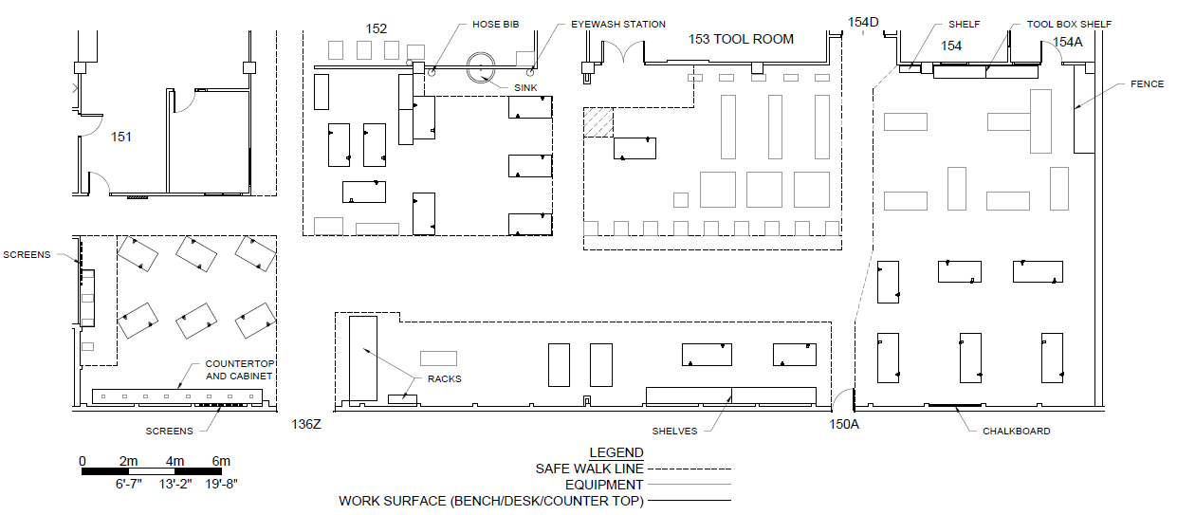
A
C
B
D
E

When beginning to examine a work area, it may be helpful to imagine how students will interact with furniture and equipment. In the example below, a shaded area has been placed at the user side of the benches to represent the full movement of a student at each bench.
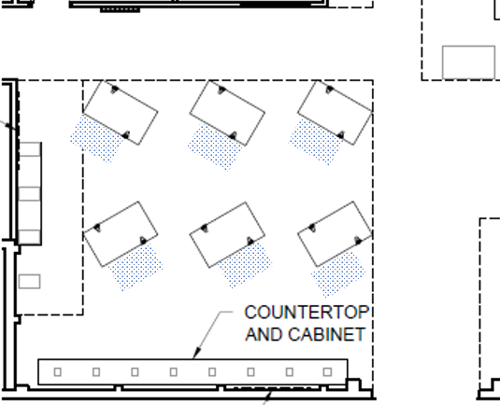
When reviewing student activity at each workbench, it might be useful imagine a 2m buffer around each student. We note that many of these circles are overlapping, and also note that the walk path around the benches is now compromised.
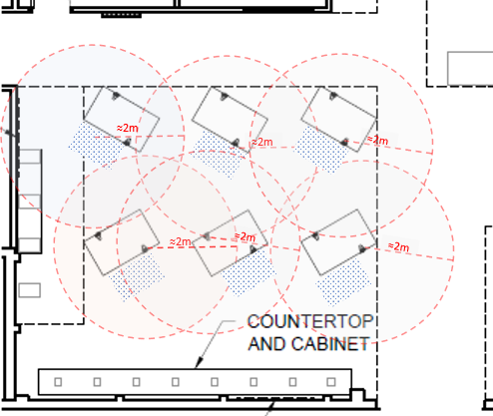

By removing several student stations and introducing barriers, the safety risks are reduced between students, and enabling a greater portion of the surrounding walkway to be utilized.
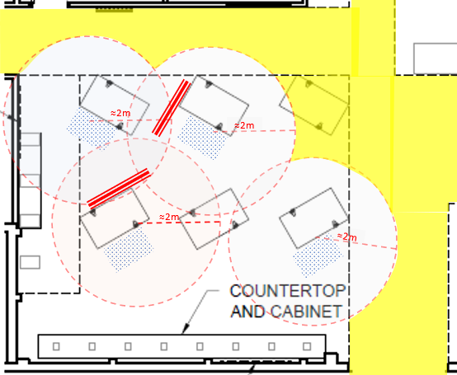

When we apply these principles to a whole shop, we have a better sense of where barriers should be placed. Note the zone directly below 153 TOOL ROOM – 3 stations could be utilized if a barrier is placed between each station. We could place additional barriers here to enable the use of more stations if desired, however because this would result in tight spaces, it is best to leave an idle station between each active station.
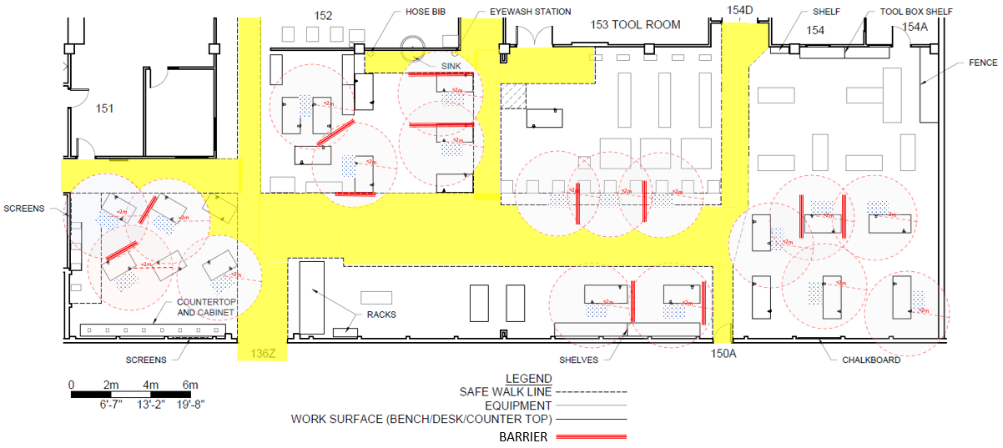
To improve safe circulation in this shop, barriers along the walkways may be useful to enhance the safety of individuals within walk paths, in addition to persons using nearby equipment.
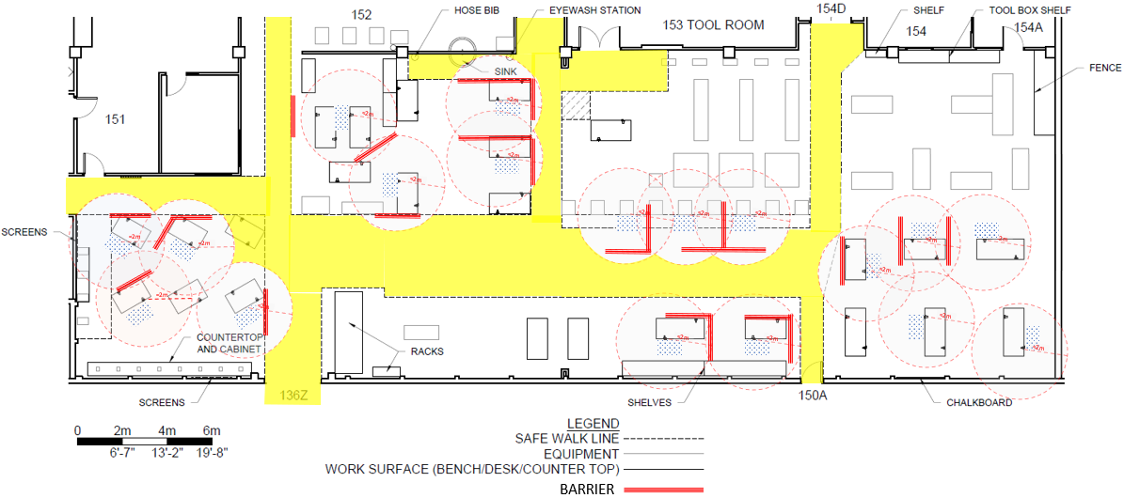

In narrow pathways, directional indicators can help prevent accidental pass-bys of people travelling different directions. In some cases, it may be necessary to include conditional directional indicators, such as the one in the centre below 153 TOOL ROOM, where a northbound path can be established if the equipment is not in use, and barriers stowed away.
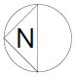
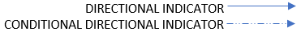
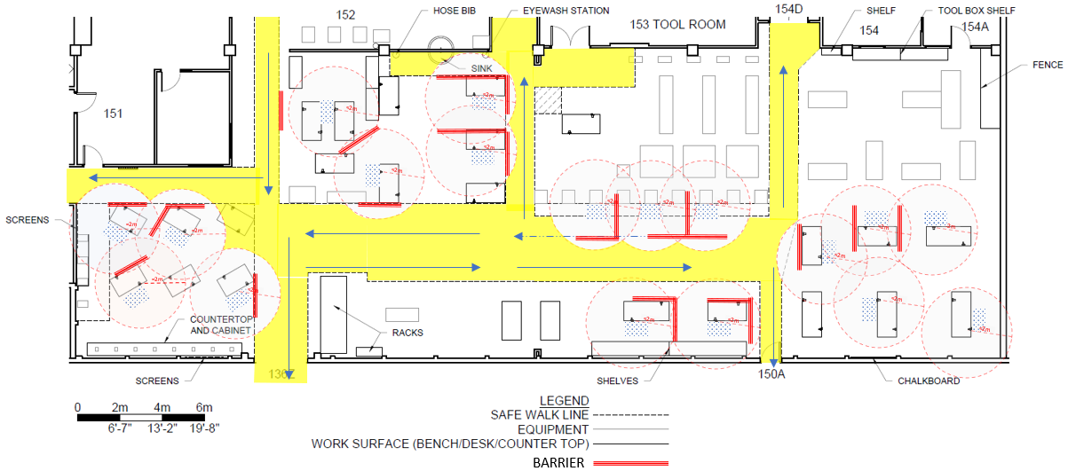

In shop areas where there are shared touch points, additional handwash stations may be required.
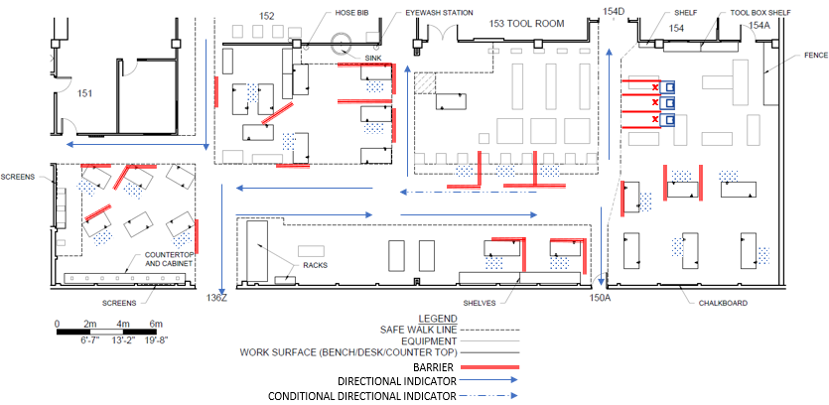

Within tight shop areas that contain blind corners, it may be useful to implement convex mirrors, audible, or visual sensors to alert users when another person is passing through a corridor to prevent accidental interactions, such as the following example:
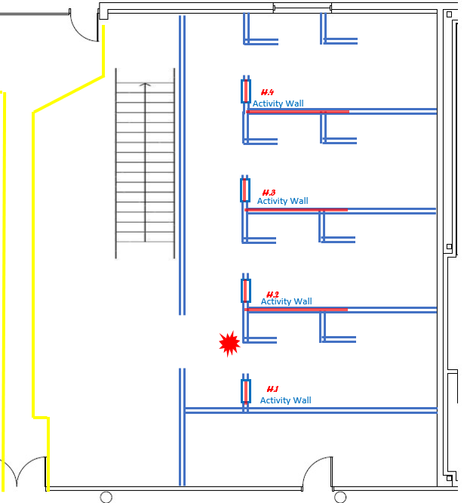
Each activity room is physically distanced from the enclosed corridor. However, someone entering this enclosed corridor could potentially conflict with someone exiting an activity room. To prevent this, a motion-activated light or strobe may help alert users to when the corridor is clear. Alternatively, a convex mirror may be implemented if there is sufficient space.

2.0 Teaching Spaces - Moveable Furniture

Teaching spaces with moveable furniture are spaces in which the furniture can be reasonably moved throughout the space. Furniture in these spaces can be moved, primarily to address physical distancing protocols, but may be supplemented by additional safety measures.

2.1 Classrooms

Classrooms typically feature tables and chairs that can be maneuvered throughout the room with relative ease. In some cases, furniture may feature table-top electrical outlets, but these can be disconnected from building power to enable furniture to move. In these spaces, furniture can be reconfigured to enable a scenario where students can move throughout the space while maintaining physical distancing at all times.

In rare situations, it may be necessary to have students enter the space first while the instructor is standing at the corner of the room or directly outside, until the instructor can enter physically distanced while students are seated. In this case, the instructor will need to exit the room to enable a student to leave to use the washroom. In other situations, it may be necessary to install a high-quality transparent barrier in front of the instructor. However, barriers in these spaces are strongly discouraged because they introduce other safety concerns.

In these spaces, floor markings (yellow hash lines) are useful visual indicators to identify safe walk paths.

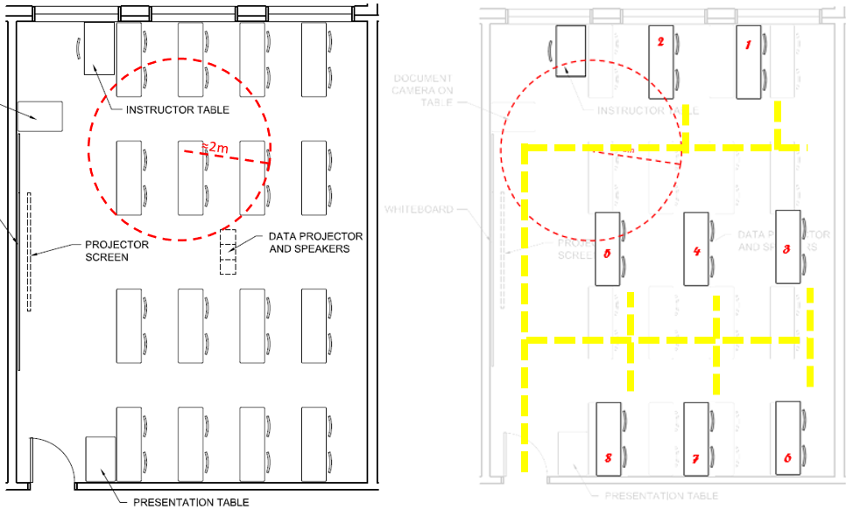
Without physical distancing. With physical distancing measures.

2.2 Drafting Labs

Drafting labs follow identical considerations as classrooms.

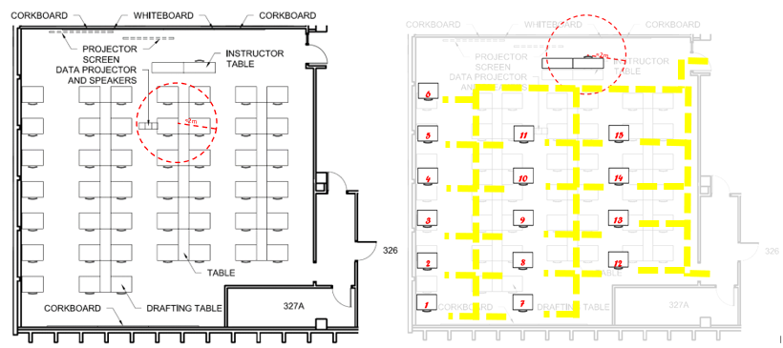
Without physical distancing. With physical distancing measures.

2.3 Computer Labs

Computer labs follow similar considerations as classrooms and drafting labs, with the exception that electrical and data connectivity solutions may be required.

With computer labs where furniture can be easily shifted, aisleways can be created to enable physical distancing – where possible, excess furniture should be relocated elsewhere.
Barriers (red lines) will be required to mitigate the reduction of physical distancing between seated stations around the perimeter of the room. If possible, the unusable workbenches in the centre of the room should be relocated.

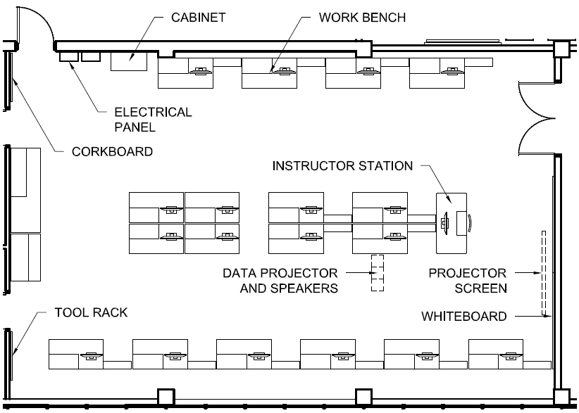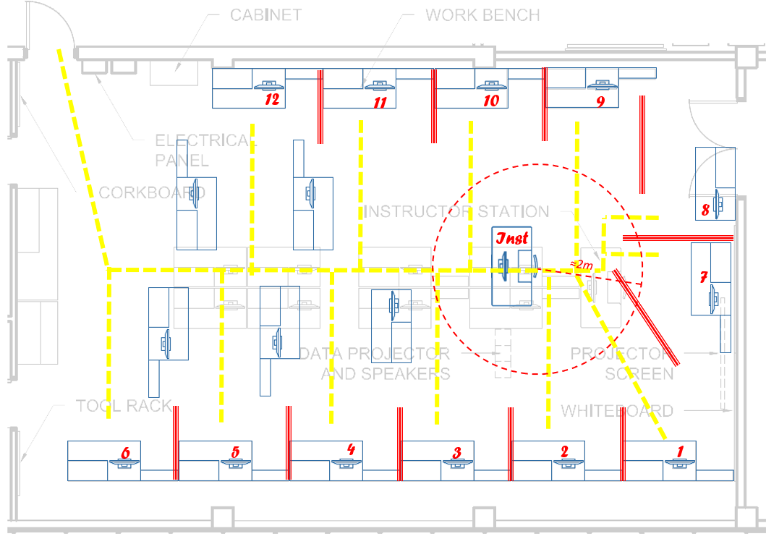
Without physical distancing. With physical distancing measures.

In other computer labs, more substantial reconfigurations may be required to enable physical distancing. For these situations, there are other considerations that may include professional moving, additional data and electrical cabling needs in addition to barrier installations which may come with associated costs.

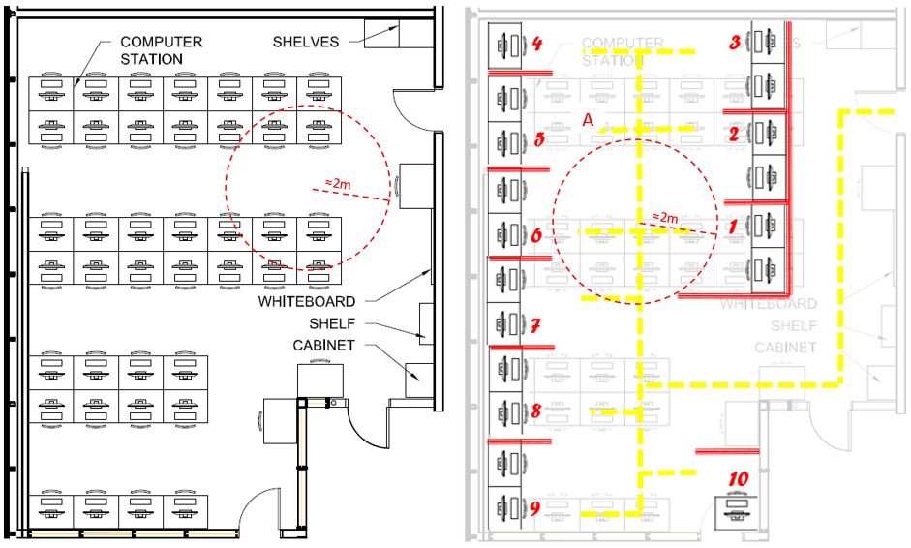
Without physical distancing. With physical distancing measures.

3.0 Teaching Spaces - Fixed Furniture

Fixed furniture teaching spaces are educational spaces where the furniture is affixed to the ground or otherwise non-moveable due to installations that require demolition/renovation or heavy lift equipment to relocate. Furniture may also have mechanical services such as plumbed gas or water supply, electrical/data, or ventilation that are tied into the furniture.

Because this furniture cannot be moved to accommodate physical distancing, additional measures need to be applied to mitigate risks.

3.1 Lecture Theatre

Because lecture halls are designed to maximize occupancy within a space, they are particularly poor spaces to conduct education during this time. Close seating proximity, combined with tiered elevations are particularly challenging. In the example below, a 110-student seat capacity lecture theatre has a revised student capacity of 6. Online learning may be a more suitable option in most cases for activity that has traditionally occurred in these spaces.
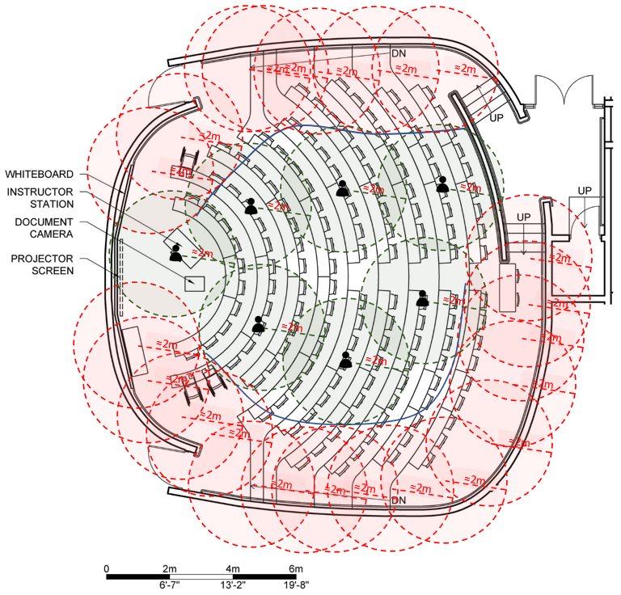

3.2 Wet/ Dry Labs with Central Demonstration Space

This subsection covers wet/dry labs where it is critical for student observe detailed activity performed by the instructor from the front of the room.

Physical barriers are useful to increase a space’s density when student stations are closer together than two metres. However, they often present visual obstruction in the form of glare when viewed from the side, or blurriness when a student is required to look through several barriers in front of them. For these reasons, barriers are not ideal when students must be able to see detailed information from the front of the room to successfully complete their practical activities. In these cases, two metre physical distancing is implemented for students while seated, and while circulating throughout a room. In the example below, some barriers have been installed, but only when they are place perpendicular to a student’s sightlines. It may be more optimal to produce pre-recorded videos that are accessible to students.
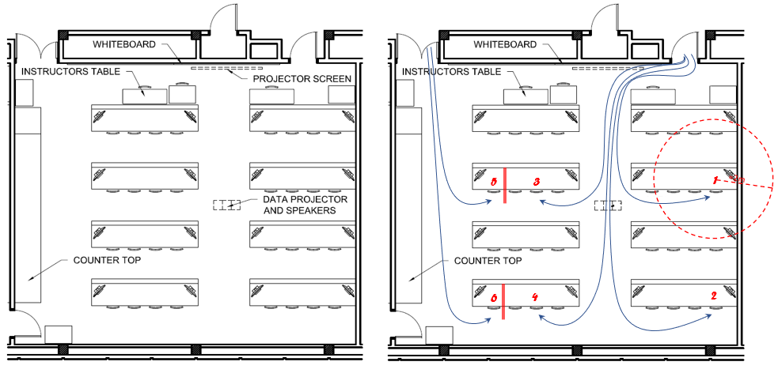
Without physical distancing. With physical distancing measures.

3.3. Wet/ Dry Labs without Central Demonstration Space

In cases where there are monitors installed on each student station that broadcasts an instructor’s activity from the front of the room, or in cases where observing front of room activities is not critical to the practical exercises, barriers can assist in increasing capacities while maintaining physical distancing.

In these spaces, an instructor may also need to consider methods to amplify their voice such as using a microphone, as barriers may also reduce the audibility or clarity of an instructor’s voice. In the example below, barriers are installed between rows to enable students to occupy every possible row without encroaching on any other students’ physical space.

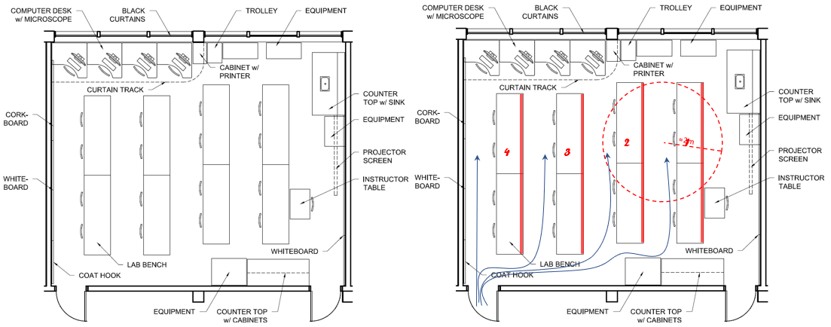
Without physical distancing. With physical distancing measures.

4.0 Learning Support Spaces

Learning Support Spaces consist of a variety of program spaces used by faculty, staff and or students. Typically, these spaces are used to store and/or issue equipment, provide individual workspaces, or provide prep areas for labs. These spaces are often small areas with limited capacity, interconnected rooms, and may have specialized features. These types of spaces are not teaching spaces, but certain precautions still need to be considered to mitigate risk.

4.1 Prep Room & Tool Rooms

Tool Rooms in shop areas are typically designed as transactional service counters, featuring racks of equipment and multiple blind corners, limiting ability for individuals to maintain physical distancing. In these spaces, having multiple occupants is strongly discouraged.
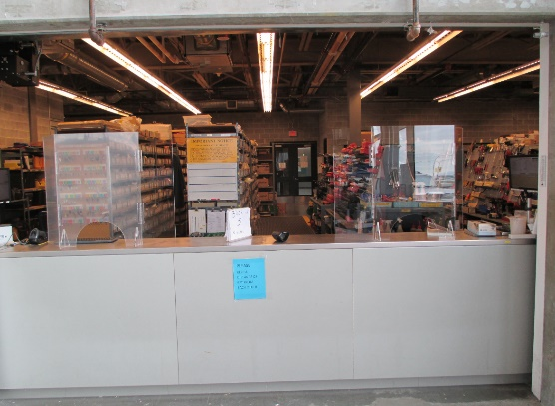
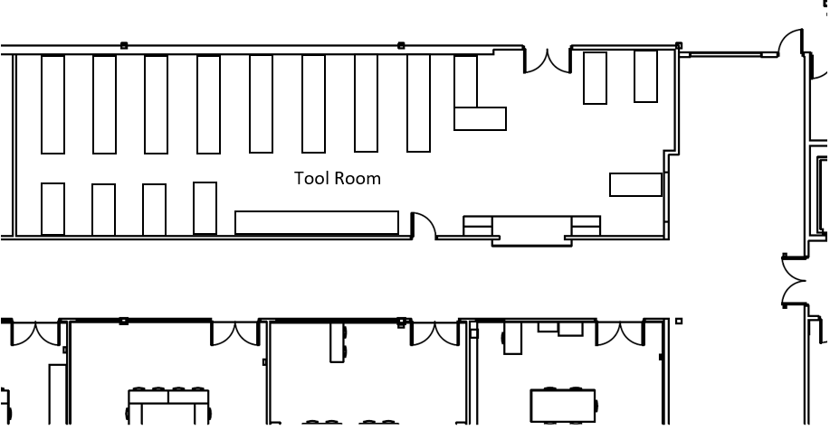

To enhance the protection of users at the service counter, barriers can enable the staff person and client to safely interact. Further safety measures may also need to implemented to reduce contamination of tools between users.

Prep rooms feature many of the same attributes as Tool Rooms, but oftentimes, contain individual rooms to enable technicians to prepare samples safely. In these situations, physical distancing is sufficiently achieved when technicians are within their individual rooms. However, there is high risk when leaving these quarters, especially given that the circulation spaces in these areas are often very narrow.

Methods to supplement communication to prevent a technician from exiting a space while another is moving through the corridor should be implemented. In this example, a motion-activated sensor attached to a strobe light could notify occupants to prevent an incident where, for example, a technician in room 107 would exit their space while a person is walking left down hallway 115. There are other solutions that could be considered such as convex mirrors, audible signals, etc.

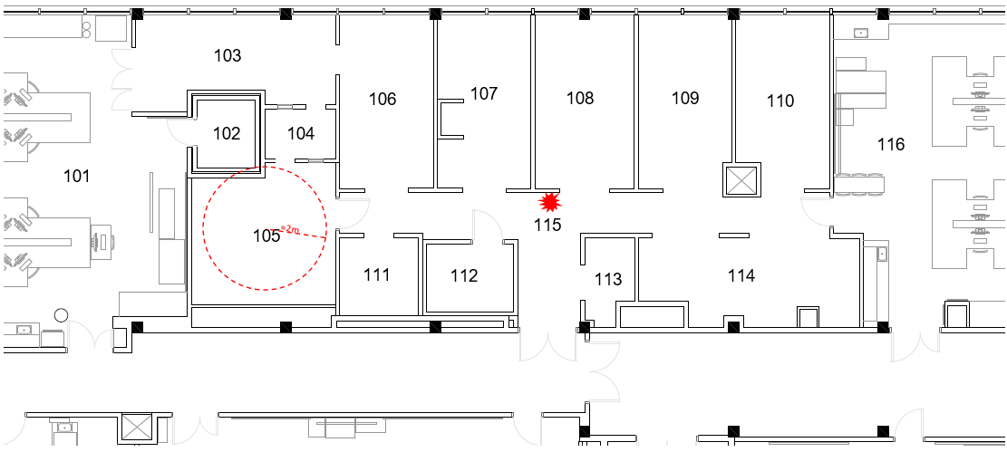

4.2. Media Studios

Media Studios exhibit many of the same features as Prep Rooms, where users of a space are physically distanced within each room, but shared use is challenging. This is due to the presence of walls, many small rooms, blind corners, and closed doors which are designed to enhance noise isolation. Consideration needs to be given on methods to supplement communication to avoid risks of physical distancing incidents. This may be achieved by the installation of sensor-activated notifications, or other controls and should be supplemented with an easily accessible room reservation system.

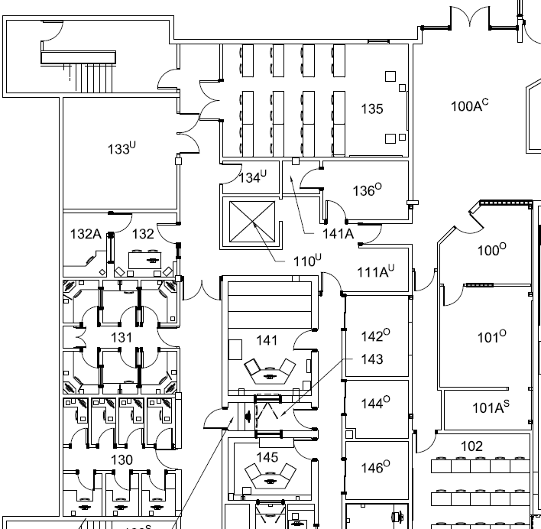

As the example above illustrates, some rooms such as 132A cannot be utilized when 132 is occupied. A notification system may be helpful for users exiting or passing by rooms 130 and 131.

