## ­

# 

Writing   
Learning  
Outcomes

# This job aid explains what learning outcomes are and how to use them in your course – whether you need to write them and design your course from scratch, or you are teaching a course that has established learning outcomes and you need to interpret them to focus your teaching, or create activities that align to them.

# In Part 1, we will define and explain learning outcome and their importance.

# In Part 2, we discuss the relationship between program goals, course level learning outcomes and module level learning outcomes.

# In part 3, we look at how to use and write learning outcomes.

# Finally, in part 4, we explore the idea of alignment between learning outcomes, assessments and activities.

# Part 1: What are learning outcomes?

Learning outcomes specify what learners’ new knowledge, skills or attitudes will be after a learning experience. A learning experience may be a course, module, class or activity, where the learning outcomes move from a more broad to a more narrow description of the expected learning.

Learning outcomes describe the context and application of the knowledge, skills and attitudes.

Learning outcomes begin with an action verb and describe something observable or measurable, and are sometimes followed by a relevant degree (sometimes also called criteria), condition and/or time limit, as they are each relevant.

Example:

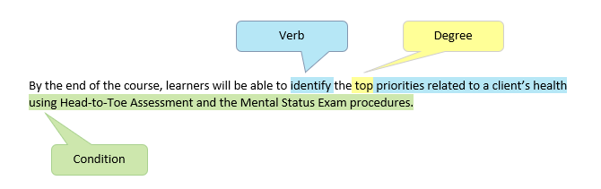

## Other Examples:

## At the end of this course you will be able to

## Design improved bias circuits using negative feedback.

## Consistently demonstrate the safe use of welding equipment with appropriate accompanying Personal Protective Equipment.

## Assess the varying impacts on the listener and social environment of reporting news during conflict or other critical situation.

## Why are learning outcomes important?

Learning outcomes are crucial to your course.

* At a high level, learning outcomes are important because they act as a benchmark for learning that guides the development of assessments and support learning activities. Broken down to more specific functions, they:
* clearly communicate expectations to learners and instructors
* define the type and depth of learning students are expected to achieve
* provide an objective benchmark for assessment: formative, summative, and prior learning assessment (see job aids on assessment in the LTC Resources for further explanation of these terms)
* are broad enough to describe the expected learning yet can be broken down in to more discrete learning points at the module level of the course
* help to prevent content creep in a course – where more and more content is added to a course, even though it may not be necessary for helping learners achieve an outcome
* guide the instructor’s design, revision or delivery of the course’s assessments, learning activities and course’s content
* help learners organize their studying
* clearly communicate graduates’ skills to prospective employers*

*By reading your listed learning outcomes on a course outline, an employer or professional in the field should be able to identify what knowledge, skills, and attitudes your students will be able to offer them after taking your course.

# Part 2: What’s the relationship of course learning outcomes to program goals or module outcomes?

## A program usually begins with Program Goals which tend to be quite broad. They are reflections of the broad skills and learning the program prepares students to achieve. These get broken down in to specific learning outcomes for each course. The course level learning outcomes can then further be broken down in to module learning outcomes, and then maybe even lesson learning outcomes that define the expected learning output for a class.

## In general, this relationship moves from more broad towards more specific and narrow descriptions of expected outcomes.

## Importantly, all levels of goals and outcomes should relate to each other. Module level learning outcomes are just more discreet pieces of learning encompassed within a course level learning outcomes. Course level learning outcomes are aligned or connected to the broader program goals.

 **TIP:** In some programs or courses, you may use competencies instead of learning outcomes. Competencies usually refer to a defined set of skills specific to an occupation and may be set by an accrediting body.

Competency statements and learning outcomes have the same purpose. They both clarify specific, observable and measurable behaviour that a learner or worker should be able to demonstrate at the end of training. The main difference between the two is that competencies are generally written by an external standardized body.

Some programs use competency statements and some use learning outcomes. The choice generally depends on whether employers and industry leaders report a need for graduates to have specific skills that meet criteria or standards from outside authorities.

In some cases, competencies may be very general. For example, a competency may be relevant to more than one course in a program. In these cases, it is useful to write learning outcomes that relate to the competencies, but are more specific to the expected learning of a particular course. See Competencies Job Aid for more specific information about competencies.

# Part 3: How do you write learning outcomes?

## For most instructors, you will be assigned a course to teach and handed a course outline that already has course level learning outcomes on it. The course outline is like a contract with students, so the learning outcomes on that course outline should not be changed until you consult with your Program Head or Chief Instructor. See also the Course Change Guidelines on the Academic Planning and Quality Assurance (APQA) website under Program Development.

## In this case, you will need to interpret the learning outcomes given to you. Use the learning outcomes to guide activities and assessments in such a way that learners can demonstrate achievement of the learning outcomes by the end of the course.

## In other situations, you may be asked to revise the course level learning outcomes for your course, or possibly write brand new course level learning outcomes for the development of a new course in your program. Or you may write module level learning outcomes of your own.

## In all these cases, it is useful to learn how to write a learning outcome so you can break it down.

## Learning outcomes generally consist of three elements: the verb, the degree (or criteria) and the condition.

## 

## Sometimes, a learning outcome may also need to include a time restriction, if relevant. For example, it may be necessary for a skill to be performed within a certain amount of time to be considered proficient for a particular profession.

## Choosing the Verb

When writing learning outcomes, it’s a good idea to start with the verb. Start with a verb that is at the right domain. Think about what you want students to be able to do, demonstrate or know on the job as a result of their learning. Focus on an actionable outcome, not a process of learning. Also, focus on what the learner needs to do for the outcome, not on what the instructor does, or the topic being taught.

We can categorize learning in three possible domains:

* thinking, knowledge (cognitive domain)
* doing, skills (psychomotor domain)
* feeling, attitudes (affective domain)

Each of these categories has different possible *levels of learning*. These range from simple recall or observation to the complex and sometimes abstract evaluation or organization of information. Bloom’s Taxonomy (1956/2001) is a useful tool to determine the appropriate level of learning expected for a particular course. It describes learning levels for each domain of learning from simple to complex. See the charts at the end of this document for an example of Bloom’s Taxonomy. You should choosea verb from the domain and the level of learning that is appropriate for your students based ultimately on what they need to do once in industry, but also where they are at in the program.

Example:

Apply change theory to the creation of a health care plan for clients in the community.

 **TIP:** If you are writing learning outcomes, make sure that the verbs you choose match the levels of learning you require for your particular course. A course early in the program probably requires a straightforward level of learning (such as Remember) than one later in the program that requires a demonstration of more complex learning (such as Evaluate), but that may not always be the case.

## Choosing appropriate action verbs

The charts on pages 6 to 8 show samples of the action verbs you could use for learning outcomes in each of these domains of learning and for each level of learning.

 **TIP:** Notice that the action verbs listed in the charts on pages 6 to 8 represent measurable or observable behaviours.

Vague verbs such as *know* or *understand* are not easily measurable. Substitute *identify*, *define*, *describe*, or *demonstrate*.

## Writing the Degree

The degree in a learning outcomes is also sometimes referred to as the criteria. The degree in a learning outcome refers to the degree of precision or the expected level at which a learner is expected to demonstrate a skill at an appropriate level.

• 100% accuracy may be implied, but less may be acceptable. If relevant, articulate the degree.

Degree can also refer to the limit to which a skill is meant to be demonstrated. For example, some theories or knowledge may have lots of applications, but there may only be certain situations learners will be asked to apply it in your course.

Example:

Apply change theory to the creation of a health care plan for clients in the community.

## Writing the Condition

The condition of a learning outcome refers to the environment, setting or conditions in which the skill is expected to be performed. For example, it may include a particular resource someone is expected to use, a particular place or environment in which the skill is to be done, or a particular constraint that applies to the learning outcome, such as the level of independence with which a skill should be done. Some examples of conditions are:

• … with a calculator

• …in a large business meeting

• … with guidance/independently

• …in the simulation lab/in the clinical setting

Example:

Apply change theory to the creation of a health care plan for clients in the community.

## How many course level learning outcomes should there be?

There should be as many outcomes as needed to clearly reflect what the students are expected to achieve to successfully complete your course. Follow these rough guidelines when deciding how many you need:

* Each three-credit course should have between five and twelve learning outcomes.

It is best to use only one action verb per outcome. For example, you would use two learning outcome statements for designing and testing a circuit:

1. Design improved bias circuits using negative feedback.
2. Test bias circuits using negative feedback.

If a learning outcome has two verbs, it is harder to measure as a student might achieve proficiency in one area, but not the other, so it is more useful to be able to measure each on their own.

Your course level learning outcomes should reflect learning that is woven throughout the course and reflect outcomes relevant to the course at large, not just outcomes that are specific to one single lesson.

# Part 4: What’s Next? How do we use Learning Outcomes for Alignment?

Once your course level learning outcomes are written, use these to help inform the design of your assessments and learning activities.

* Each assessment should measure the learning outcome it aligns to.
* Each learning activity should help learners practice and improve on their skill related to a course level learning outcome. The activities should help a learner build towards successful achievement of that learning outcome in the assessment.

**Example:**

**Learning Outcome:** Apply change theory to the creation of a health care plan for clients in the community.

**Learning Activities:**

* Students discuss a range of change theories and how they would impact various clients.
* Students practice writing care plans for case study clients and identify challenges to implementation.

**Assessment:**

* Students create a care plan for clients in the community and describe the change theory they will use to implement it and how the change theory is appropriate to the plan and the clients.

 **TIP:** If you are teaching from a course outline that already has learning outcomes written for you, you will be thinking a lot about activities. To plan your activities, think about the verbs in your learning outcomes and how you can help learners achieve those outcomes.

What do you expect students in your level in your program to be able to do? What level of learning is appropriate for the learning outcomes you’re working towards?

What kind of activities will help learners achieve the learning by the end of the course? What kinds of activities can you scaffold, or slowly build on so there can be success by the end of the course?

For more information on alignment, take a look at the LTC job aid Course Development.

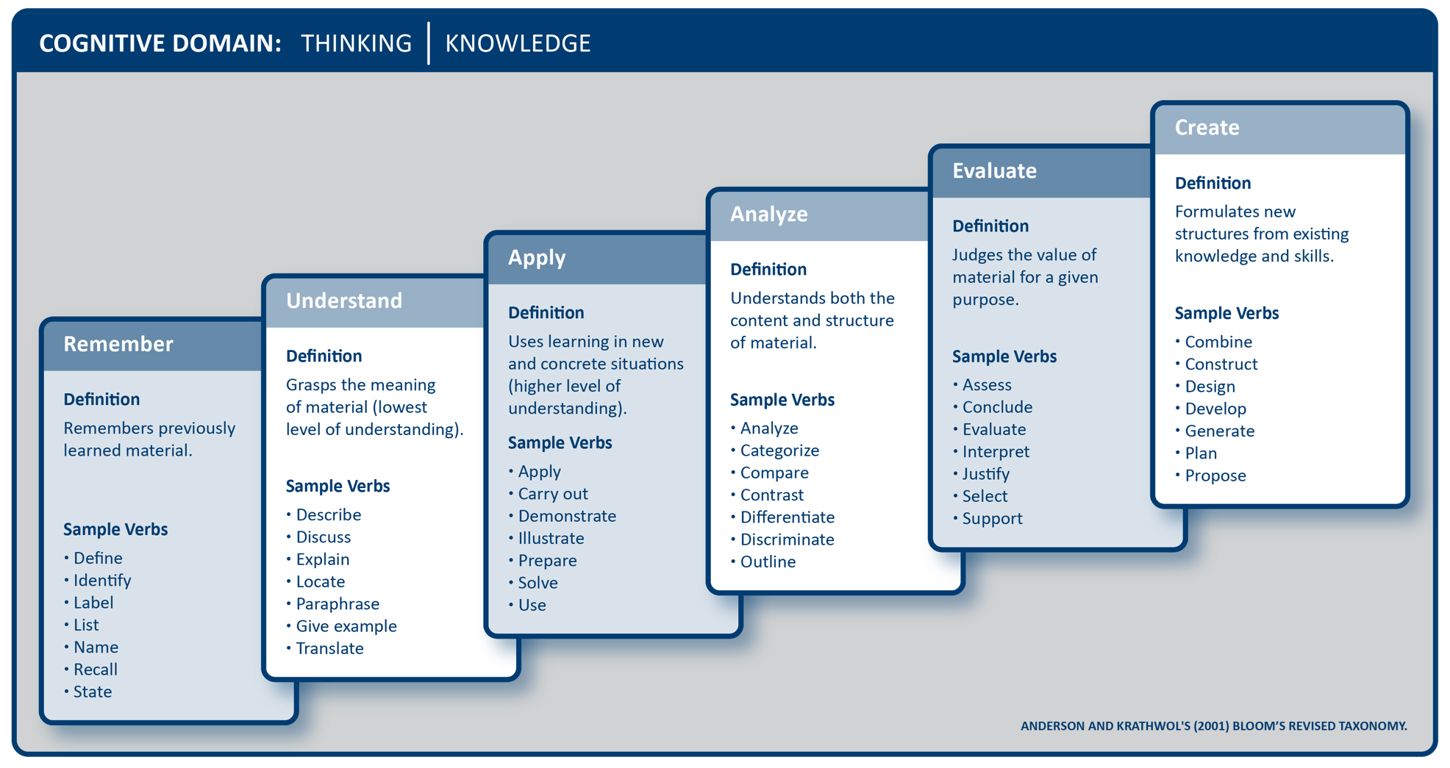

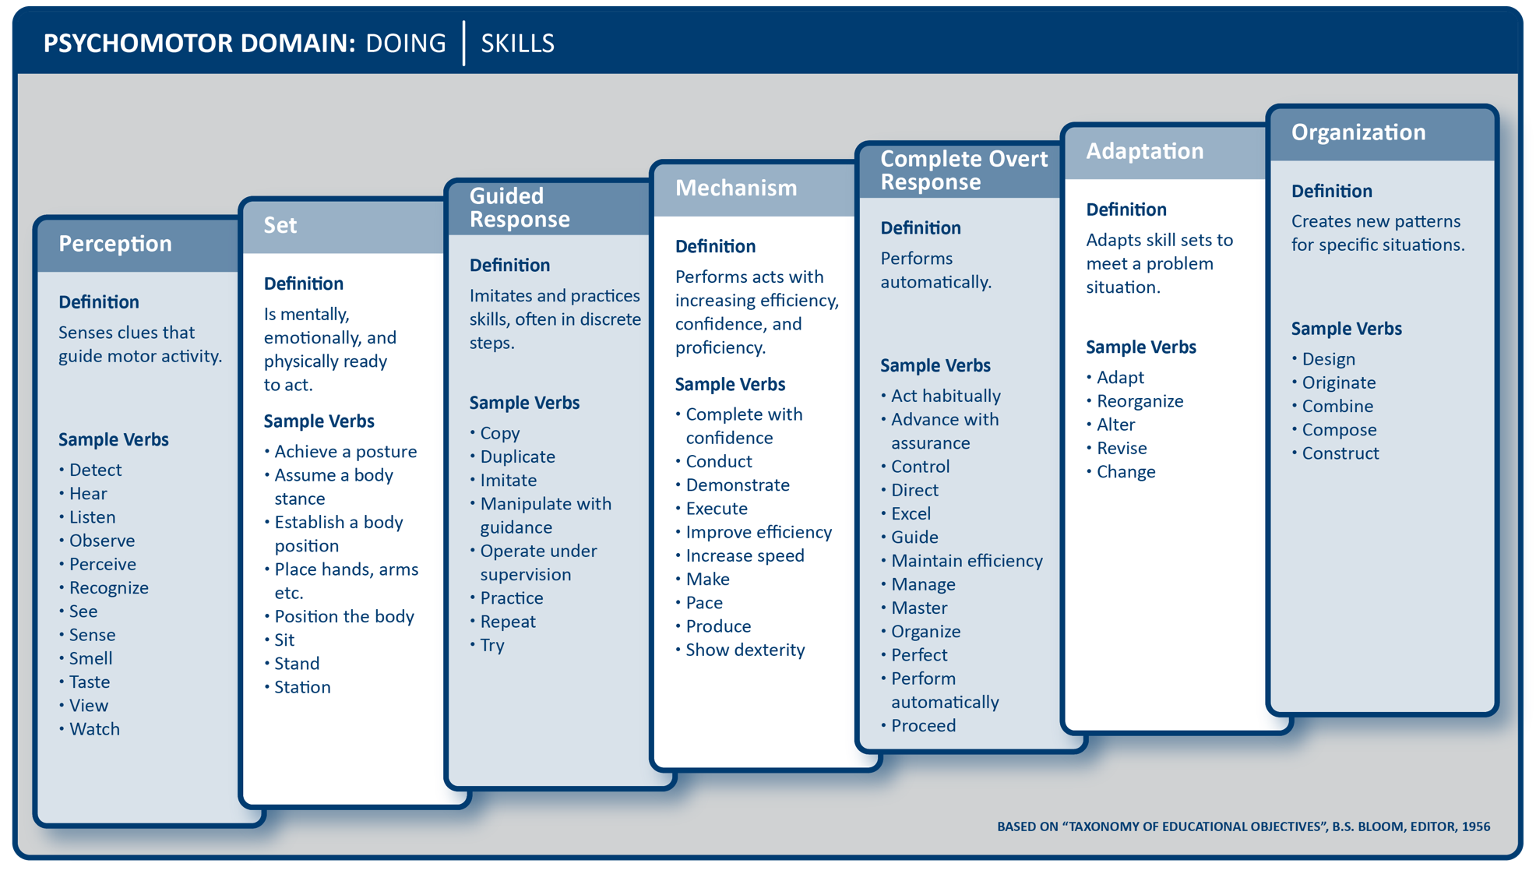

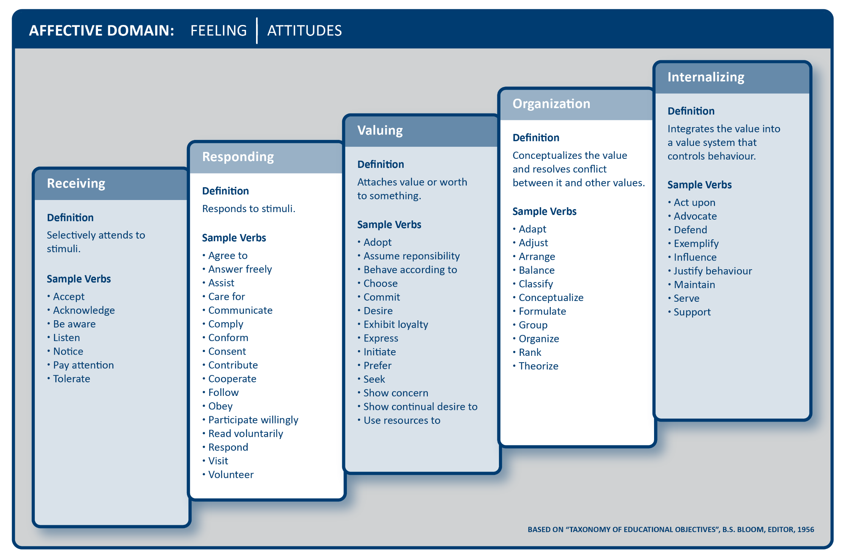

Checklist for writing learning outcomes

Use the following checklist to help you as you write your learning outcomes. Each assessment and learning activity should measure the learning outcome it aligns to.

When writing learning outcomes, I need to:

* Focus on actionable outcomes, not processes
* Start each outcome with an action verb
* Use only one action verb per learning outcome
* Avoid vague verbs such as know and understand
* Check that the verbs used reflect the level of learning required
* Add an appropriate condition and/or time limit and degree (criteria) as relevant and required
* Ensure that outcomes are observable and measurable
* Write the outcomes in terms of what the learner does, not what the instructor does
* Check that the outcomes reflect knowledge, skills, or attitudes required in the workplace
* Include outcomes that are woven into the entire course (such as work effectively in teams)
* Check that there are the appropriate number of outcomes
* Check that the outcomes fit within program and course goals
* Ensure that module level learning outcomes align to the course level learning outcomes

2022 Learning and Teaching Centre at BCIT is licensed under a Creative Commons Attribution-Share Alike 4.0 International License.

3700 Willingdon Avenue, Burnaby BC V5G 3H2 • Tel (604) 432-8927 • F[ax (604) 431-7267 • http://www.bcit.ca/ltc](http://www.bcit.ca/ltc)