Course Development Guide

Designing a Course
Before starting to develop or revise a course (online or face-to-face), please consult with your program head and the instructor(s) who teach(es) the prerequisite courses or the course(s) for which your course is prerequisite. You need to know:
- The requirements in the related courses (learning outcomes, major topics, assessment, etc.)
- How your course is related to the program goals.
- Who your students are: e.g., their previous knowledge, learning skills, etc.
Information like this will help you position your course in the program curriculum, avoid gaps and redundancies with other courses, and start your teaching at an appropriate level.
Check out the resources below when developing face-to-face, fully-online or blended courses (including flipped classrooms). Feel free to contact your School Liaison for more information and support.
Learning Outlines
- Develop or revise learning outcomes that align with current industry needs and emphasize students’ capability to perform job-related tasks.
- Outline a brief evaluation plan that truly assesses the student’s achievement of the learning outcomes.
- Develop or revise the course outline using the Course Outline Template [Word doc] (Instructions: Use F11 to move to next field.)
- Get your course outlines approved by your program head and Associate Dean
Course Plan

- Determine or verify student workload according to BCIT Policy 5012.
  - Student workload = classroom hours (or equivalence) + preparation/homework hours. Usually, you estimate student workload based on the amount of time an average student in the program completes per hour.
  - Consult your program head and other instructors about the number of hours student spend in preparing for classroom learning and working on homework.
  - Keep this number in your mind when you design/revise a course. Avoid overwhelming your students and yourself!
- Map out your course using the Course Plan Template.
This helps you achieve “constructive alignment” (Biggs, 1999) among learning outcomes, assessment methods, and learning/teaching activities. The alignment has a student-centered focus and ensures:
  - All learning outcomes are addressed and assessed.
  - Assessment methods chosen are aligned with learning outcomes and are meaningful and related to real life tasks
  - Student workload is balanced during the term and more emphasis is given to major or more difficulty learning outcomes.
  - Choose instructional strategies and design learning activities that foster active learning, accommodate diverse learning preferences, and help students achieve the learning outcomes.
  - Estimate your own workload. It should feel reasonable!

Biggs’ Theory of Constructive Alignment (Adapted from Biggs, 1999)

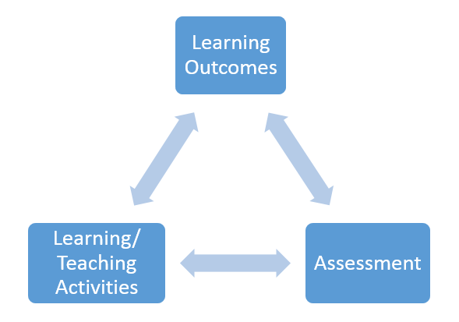
Diagram 1: Bigg's Constructive Alignment
Many educators suggest using the Backward Model (Wiggins & McTighe) when designing a course as it helps you achieve constructive alignment. A more pragmatic benefit of using this model is to help you stay focused on what you want to achieve without overwhelming your students and yourself.
“Our lessons, units, and courses should be logically inferred from the results sought, not derived from the methods, books, and activities with which we are most comfortable. Curriculum should lay out the most effective ways of achieving specific results… in short, the best designs derive backward from the learnings sought.”
      - Wiggins & McTighe (p14)

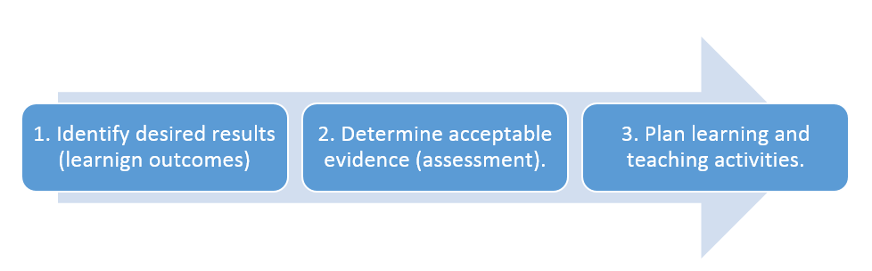
Diagram 2: Stages of Backward Design

See more resources at Enhancing Learning and Teaching, such as active learning and authentic assessment.

Developing Lesson Plans
- Preparing Lesson Plans [PDF]
All instructors plan for learning, especially novice instructors. A poorly planned lesson can rarely be delivered well, and a well-planned lesson can rarely be delivered poorly. Lesson plans provide guidance for course delivery. After designing a course (using the Course Plan Template), prepare a lesson plan for each lesson, no matter whether it is as short as 10 minutes or lasts 3 hours.
As you plan your lesson keep in mind your students: who they are, what they already know, why they should learn this, what they must learn and what they must do in order to learn. The instructor and students each do different things at each stage of the lesson. Each part should flow smoothly into the next.
The planning usually takes more time than the delivery. However, it helps you envision potential delivery issues and prepare for solutions. In addition, lesson plans are a crucial tool for reviewing and improving your course.

Producing Course Materials
Once you have designed a course (learning outcomes, assessment plan, and learning activities), you start producing course materials for teaching and learning, which can include a PowerPoint presentation, course notes, assignments, and online course sites, etc. Course development is an ITERATIVE process. You may want to start at any point rather than following the Backward Model, but make sure you check the alignment of learning outcomes, assessment, and learning activities as you progress.

See more resources at Enhancing Learning and Teaching,

If you plan to use educational materials such as texts or readings, you must make sure they are in the BCIT Bookstore before the first class, as BCIT faculty are prohibited from selling materials directly to the students.

If you are using course materials developed by others, you need to ensure that you are respecting copyright restrictions. Luckily, at BCIT, copyright experts can support you every step of the way.
- Copyright at BCIT, or
- Using the Copyright Decision Tool
- Avoiding Plagiarism - a 5-minute video from the BCIT library
Outside BCIT, the Purdue Online Writing Lab has other in-depth and helpful resources on plagiarism, including samples to discuss.

Reviewing Your Course Design before Delivery
- Use this Online Course Checklist [DOC] as a guideline when developing your online course (Use it as a reference for developing a face-to-face course as well). Or,
- Use the lesson plan checklist in Preparing Lesson Plans.

Seeking Course Development Support
The Instructional Development Consultants (IDCs) help you with the pedagogical aspects of Course development. Other LTC services groups can produce materials for you (e.g., images, video, and multimedia objects) and provide technical support for course production. Feel free to drop in our centre, participate in our workshops, or collaborate on course development projects (see Course Development Models). An easy first step is to contact your LTC School Liaison.

BCIT Policies/Templates Related to Course Development/ Revision
- Course Outline Policy and Procedures
  - Policy 5403: Course Outlines and Course Names [PDF]
    - Procedure 5403-PR1: Course Outlines Process [PDF]
    - Procedure 5403-PR2: Course Names Process [PDF]
- Assigning of Credits to Courses Policy: Policy 5012.
- Course Outline Template [Word doc]
References

- Bowen, Ryan S., (2017). Understanding by Design. Vanderbilt University Center for Teaching. Retrieved on Oct. 20, 2017 from https://cft.vanderbilt.edu/understanding-by-design/.
- Wiggins, G., & McTighe, J. (1998). Backward Design. In Understanding by Design (2nd edition). USA. ASCD.
- Biggs, J. B. (1999, 2001). Teaching for Quality Learning at University, Buckingham: Open University Press.

